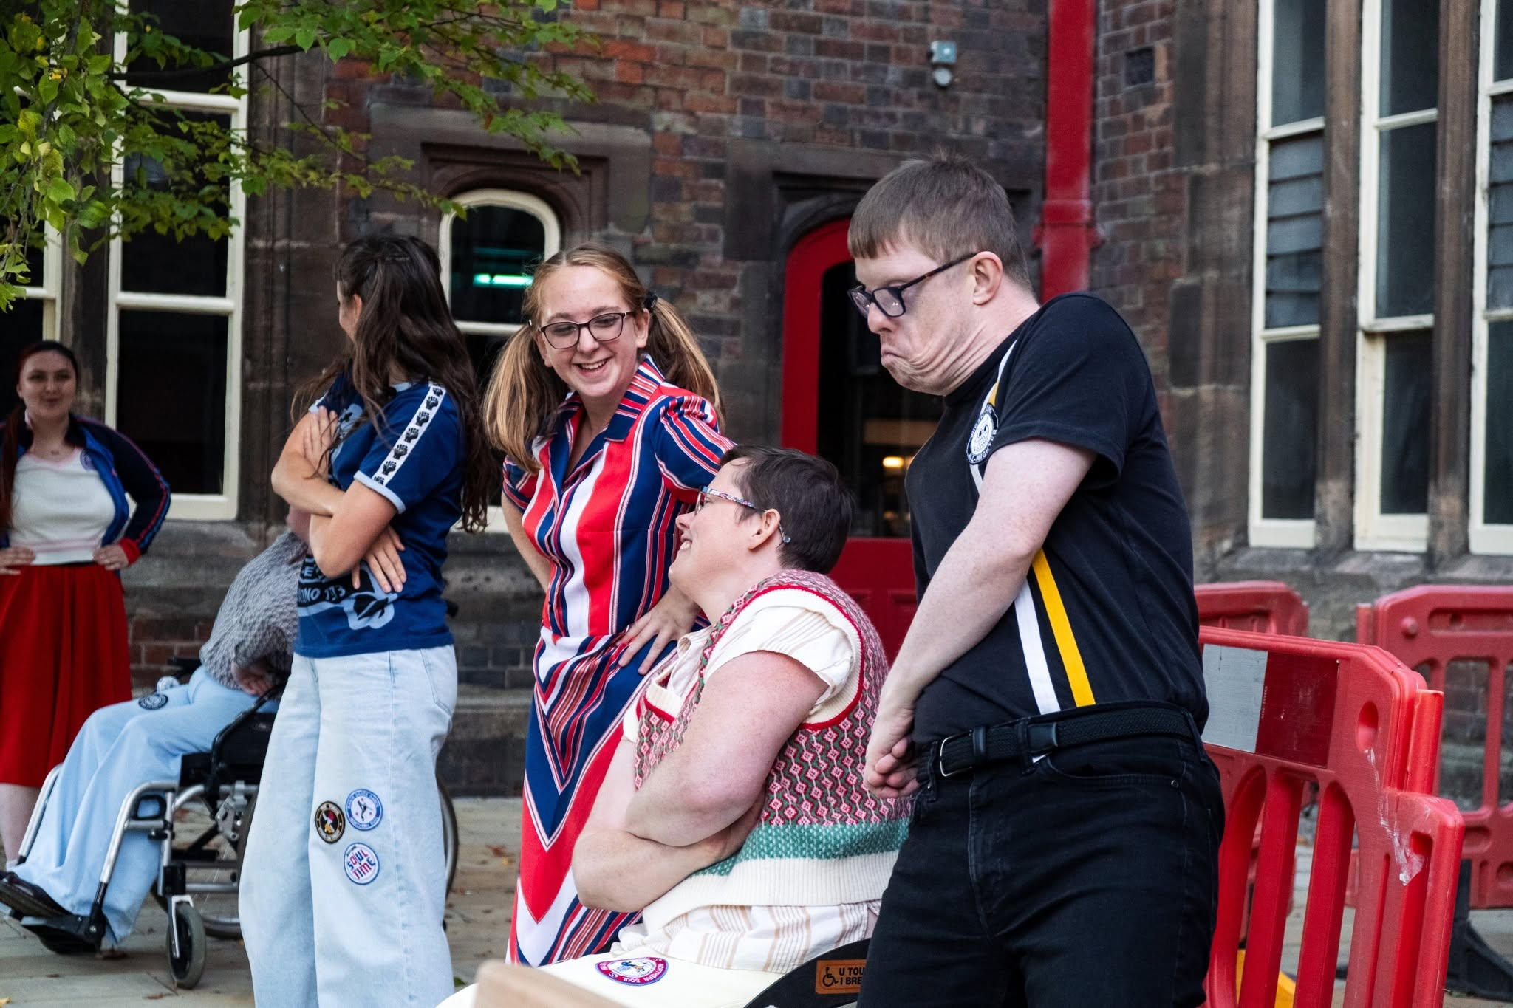

FRONTLINEdance is entering an exciting new chapter. As we approach our 25th anniversary, we are appointing our first Executive Director to co-lead alongside our Artistic Director and Board to strengthen the organisation and lead its next phase of growth.

This is a pivotal role for an experienced, values-led leader who can bring strategic direction, financial confidence and operational stability, while sharing our belief in the power of dance and the arts to create greater equity,
connection, belonging and opportunity for d/Deaf, disabled and neurodivergent people, those with long term health conditions, and hospital patients.

You will lead on the organisation’s legal requirements, financial sustainability, fundraising, operations, strategies, people and organisational development, working collaboratively with the Artistic Director to realise FRONTLINEdance’s artistic ambitions. You will help ensure the company is well-positioned to grow its impact locally, nationally and beyond.

You will have the unique opportunity to shape strategic initiatives, build strong relationships with stakeholders, and advocate for rights-based inclusive arts.

We celebrate diversity and inclusiveness and are committed to providing our employees with the tools they need to succeed. If you are a strategic thinker with excellent communication skills and a proven track record in leadership, we invite you to apply and help us shape the future of FRONTLINEdance together!

This position follows a 12-month recruitment drive to cultivate the right people to build our team and strengthen our foundations.

We believe that now is a great time to join us and co-lead us!



“FRONTLINEdance wants Stoke-on-Trent & North Staffordshire to be a place where d/DEAF, Disabled, and Neurodivergent people, hospital patients, and those with long-term health conditions, can enjoy arts & culture with ease, & thrive as artists, leaders, makers, producers.” - Rachael Lines, Artistic Director

About FRONTLINEdance
FRONTLINEdance is an artist-led company based in Stoke-on-Trent, placing d/Deaf, disabled and neurodivergent people (dDDN), hospital patients, and those with long-term health conditions (LTHC) at the core of our organisation as leaders, dancers, artists, and audiences.
Established in November 2001, as a not-for-profit Company ltd by guarantee, FRONTLINEdance is now a proud Arts Council England, National Portfolio Organisation (2023-2028).
FRONTLINEdance deliver a range of activity including:
- Dance sessions in the community and in hospitals in Stoke-on-Trent; including but not exclusively in, Abbey Hulton, Blurton, Hanley/City Centre, Trent Vale, Norton, Hartshill and Tunstall, plus Stone, Leek, and sessions online for national reach and access.
- Creating and touring professional, inclusive contemporary dance work often with live music, mainly to non-conventional theatre settings, including outdoors and hospitals, and producing screen-dance films
- Supporting, nurturing and training dDDN artists, including those with LTHC
- Supporting other arts organisations to ensure they are also inclusive and accessible, striving for equity in the arts and the culture sector
- Collaborative Arts project for parent-carers
- Performance Opportunities for our community including a new project for those with acquired brain injury
- Programming and commission dDDN artists / companies
Our work often includes collaborating with composers, musicians, film-makers, creative writers, costume designers, photographers, visual artists, spoken word, poets, theatre makers, BSL interpreters, audio describers and creative enablers. We co-design, co-create and co-produce our work mainly with our local community and the artists we work with.
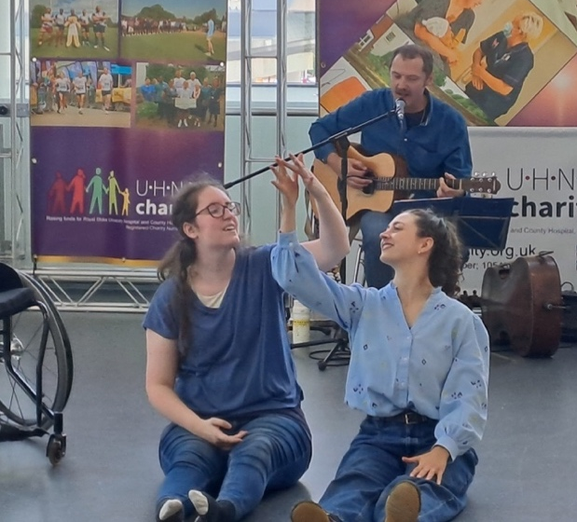
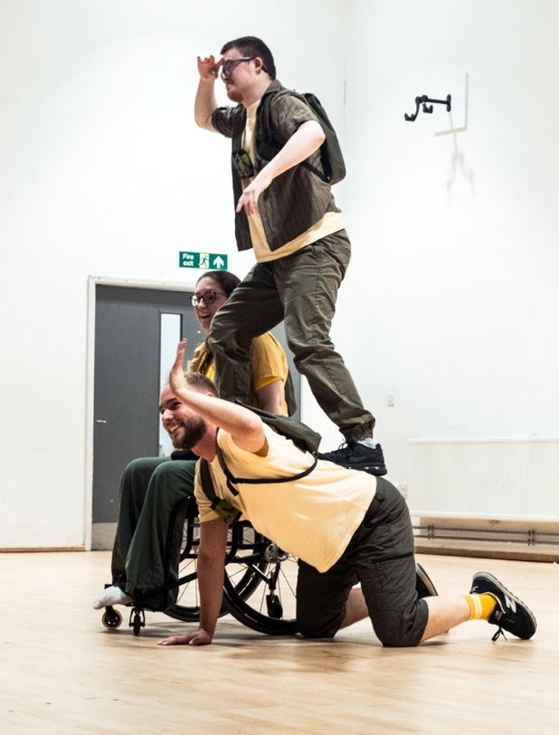
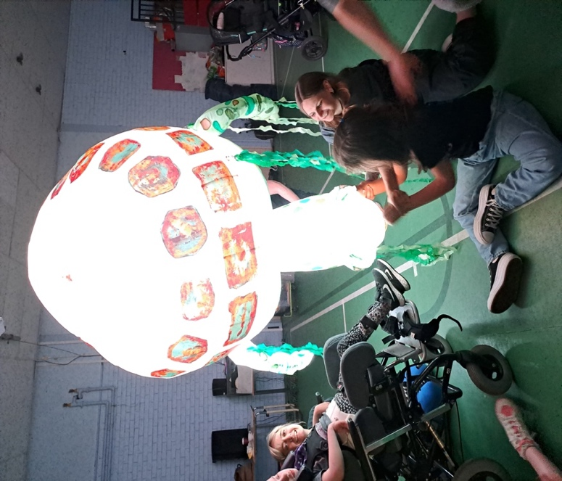
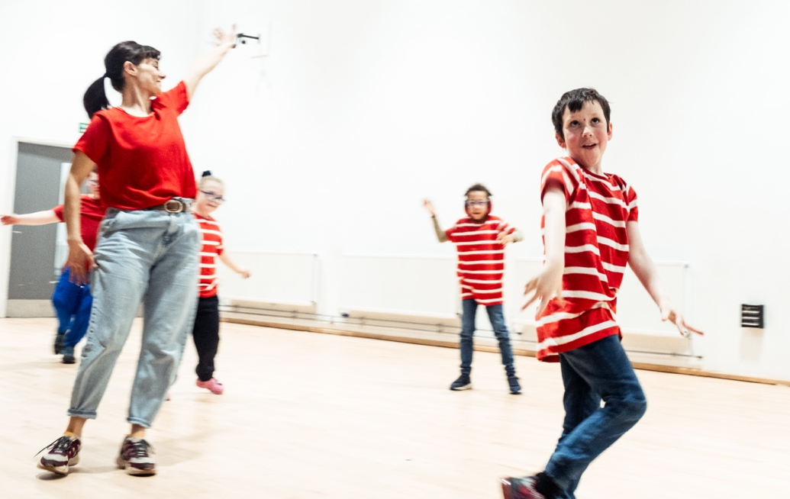

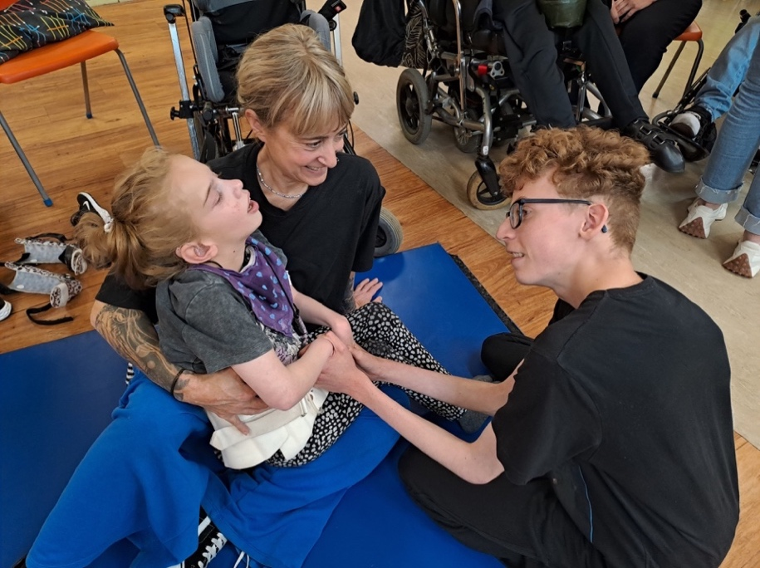

General Information: Executive Director Role

Reports to: Board of Directors
Responsible for: People and Operations Manager, Project Managers, and Evaluators (PAYE &Freelance).
Hours of work: Office hours of 7.5 hours a day are usually worked between 8am –7pm, Monday to Friday. On occasion, you will be asked to work on an evening or at the weekend.
Place of work: The company’s new base – The Dudson Centre, Hope Street, Hanley, Stoke-on-Trent. Hybrid working can be considered for part of the role; however, regular attendance at the Company’s base will be required. How this might work can be discussed at the interview. Your role will include visiting stakeholders and developing new partnerships, which means travelling outside of the area is required. Nearby parking is £1.50 per day, plus free car parking on a rota basis in the staff car park.
Probation period: 6 months
Notice period: 1 month during probation and 3 months thereafter
Terms: Permanent, 37.5 hours per week
Annual Leave: 25 days per annum, plus public holidays
Salary: £38,000-£40,000 per annum (dependent on experience) with 3% pension contribution alongside your contribution of 5%, with The People’s Partnership, which you can opt out of if you wish. This position will be responsible for investigating additional company benefits, updating the employment handbook, and introducing new ways of working as required.
TOIL: will be accrued for work outside of and over normal hours. Overtime pay is not offered.
Experience: To fulfil this role, you must have at least 5 years of experience significant experience in senior management, organisational leadership or a comparable level of responsibility. The level of pay will be determined by the level of your experience and what you can be held accountable and responsible for.
Training: Available as required.
Start date: As soon as possible. We are happy to negotiate for the right person.

FRONTLINEdance wishes to encourage applications from those underrepresented who often find barriers to employment and senior roles (people with protected characteristics). This includes but is not limited to; d/DEAF, disabled and neurodivergent people, women, single parents, and those with a Global Majority identity.

FRONTLINEdance value lived experience. We are inclusive and aim for our recruitment process and roles within the company to represent this, be welcoming and accessible. If you find anything inaccessible to you, please tell us.
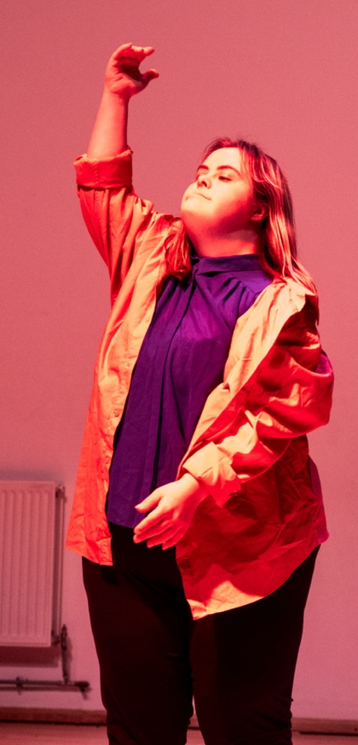
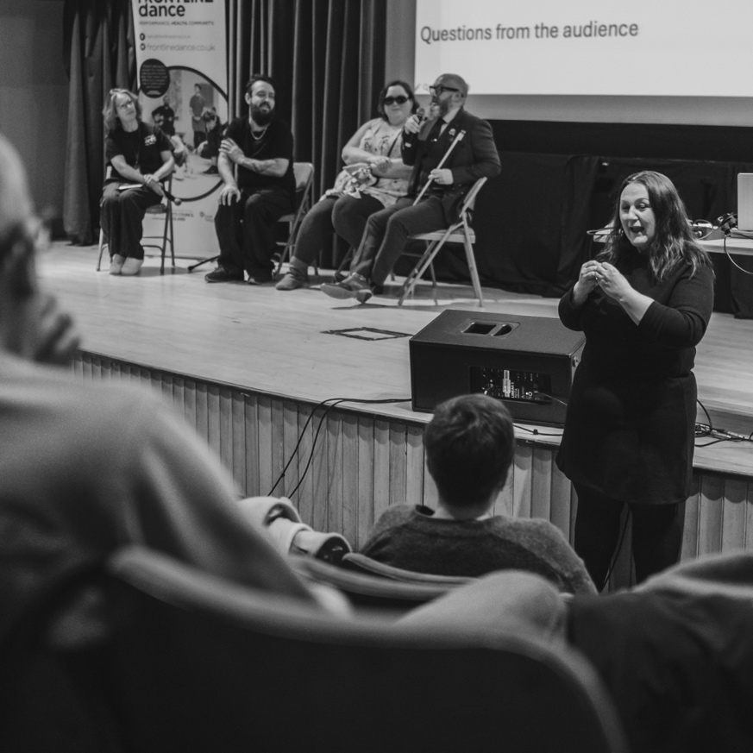
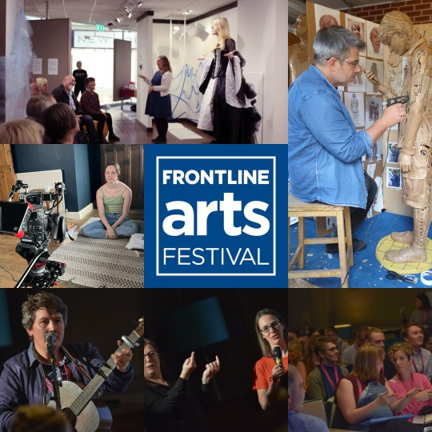
Links to other versions of this information can be found on our website: https://frontlinedance.co.uk/news-and-updates/

Role and Responsibility

We expect those applying to meet these essential requirements and have the necessary experience to carry out the role effectively and confidently. To help us gauge this, we ask all applicants to fill out an online form that can be found listed below within the How to Apply section. We understand that some applicants may be very experienced in some aspects of the job, but not all. We’d still encourage you to apply. This is a guide to the nature of the work required of this position. It is neither wholly comprehensive nor restrictive and will be reviewed regularly to ensure its accuracy and validity.

- Strategic and Operational Leadership: to work with the Artistic Director and Board to set the company's overall direction and long-term goals, ensuring ambition, sustainability and compliance.
- Lead on: fundraising, finance and organisational management
- Decision-Making: to work in close partnerships with the Artistic Director and Board to deliver the organisation’s vision and business plan, making critical decisions regarding operations, finance, marketing, and business development.
- Public Face: to often act as the company's spokesperson and represent it to stakeholders, including investors, customers, and the media.
- Team Leadership: Lead, motivate and oversee a hybrid workforce (FTE, part-time, freelance, project-based staff and volunteers). Promote a positive organisational culture that encourages employee engagement and professional growth.
- Reporting to the Board: to be accountable to the board of directors for the company's performance. Playing a key role in ensuring the organisation is financially robust, well-governed, and forward planned.
- Manage Risk: Lead on risk management, liaising with the whole staff team, board and stakeholders.
- Reporting and Accountability: Drive delivery of the Arts Council England’s National Portfolio Organisations conditions, requirements and reporting. Ensure compliance with Arts Council England National Portfolio requirements, governance, and reporting.

- Finance: Hold responsibility for financial management, budgeting, and cashflow. Set, manage & evaluate budgets. Update cashflow monthly, and produce quarterly management accounts for the board and our funders. Increase and Diversify FRONTLINEdance’s income streams, including co-writing applications (grants, commissions, tenders). Oversee book-keeping, and payroll.
- Partnership Development - Develop long-term partnerships related to specific strands of the company’s work. Implement new ways of approaching and retaining partners.
- Support and enable the Artistic Director in delivering creative ambitions.

Duties
- Prepare and monitor budgets, forecasts, and financial reports, including monthly and quarterly Board reporting, ensuring transparent accounting.
- Lead submission of funding bids and investment proposals
- Line manage operational and project staff
- Coordinate business planning cycles and organisational reviews
- Ensure timely delivery of reporting, evaluation, and KPIs
- Support organisational risk management and mitigation planning
- Facilitate team communication across hybrid working structures
- Co-lead organisational leadership, culture, and decision-making

Who are we looking for?

In this pivotal role, you will collaborate with our dedicated team to set the strategic direction of FRONTLINEdance, while fostering a culture of authenticity and inclusivity. You will be responsible for overseeing daily operations, ensuring that our mission aligns with the needs of our community and stakeholders. Your leadership will empower those around you as you work to build partnerships, enhance our programs, and advance our organisational goals. This is an opportunity to take charge alongside our Artistic Director. You’ll be making a lasting impact while embracing a friendly and collaborative work environment, for a company that is often described as ‘niche’.

Applicants should also be strong advocates for programming and connecting to those who are harder to reach (due to geographical, social or economic limitations).

Essential Skills & Experience
- 5+ years of significant experience in senior management, organisational leadership or a comparable level of responsibility.
- Robust understanding to competently lead FRONTLINEdance as a not for profit, arts organisation, in Stoke-on-Trent.
- Proven track record of generating income, including fundraising and grant writing.
- Strong financial management experience, including budgeting and forecasting.
- Experience managing hybrid teams (full-time, part-time, freelance).
- Strong understanding of National Portfolio Organisations requirements and public funding frameworks.
- Experience in strategic planning and organisational leadership.
- Excellent organisational and forward-planning capability.
- Strong partnership-building and stakeholder management skills.
- Competent and experienced in Risk Management
- Ability to work collaboratively with creative leadership (Artistic Director)

Desirable Skills & Experience
- Previous experience as an Executive Director or General Manager, or similar role in equivalent organisation
- Experience within dance, participatory arts, disability or arts & health sectors
- Knowledge of Stoke-on-Trent / regional cultural ecology
- Track record of diversifying income streams (earned income, partnerships, philanthropy/individual giving)
- Experience leading organisational change or growth
- Familiarity with evaluation and impact reporting in arts & health contexts
- Understanding of the current Investment Principles held by Arts Council England
- The potential to follow official charity regulations, data protection rules, and governing documents.
- Knowledge of Permitted Work, Access to Work
- Direct experience of working alongside d/DEAF, disabled, and neurodivergent people
- Understanding of long-term and chronic health conditions and how they can impact workflow
- Understanding how the menopause can affect women, and the importance of creating an environment where it can be received with openness, understanding, adaptability, and respect.

We expect all those who work for FRONTINEdance to:

Champion and uphold FRONTLINEdance’s values and policies. Ensure inclusion and access are embedded and at the centre of all we do, then advocate this externally. The social model of disability initiates are methodology and decision-making. As does our lived experience.
Share our vision for Stoke-on-Trent and North Staffordshire to be a place where d/DEAF, disabled and neurodivergent people can enjoy arts and culture with ease and thrive as artists.
Support FRONTLINEdance to deliver with quality, an ambitious activity plan that embeds the Arts Council England’s shared Investment Principles and #Let’s Create strategy.
Advocate for access and inclusion widely, and introduce FRONTLINEdance to potential supporters, partners, and investors.
Be objective with the ability to scrutinise and question decisions, planning and delivery.
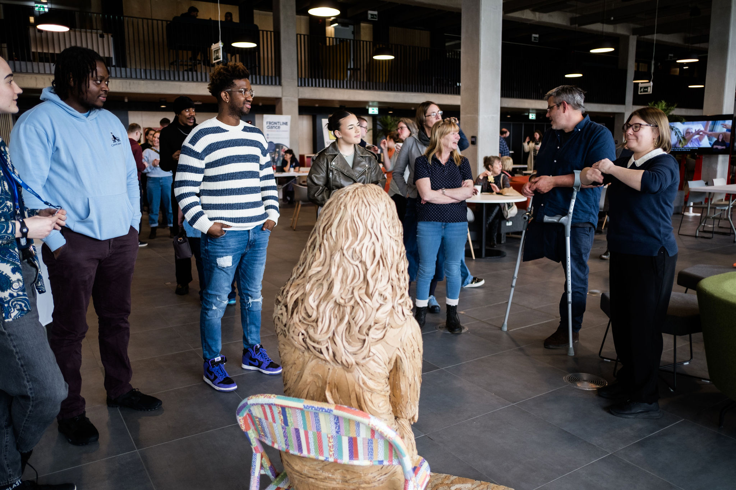

Recruitment Procedure:

Deadline to Apply: 18th September at 5pm 2026
Selected applicants will be invited to interview by: 24th September, 5pm.
Interview Dates: Saturday 26th September*, Stoke-on-Trent 11:30am-5pm (end time will be dependent on interview slot). A second online interview may be scheduled on either Monday 28th & 29th September 2026 between 4:30pm and 6:30pm.
*FRONTLINEdance will be holding a public AGM on Saturday 26th September, where successful candidate’s will be able to mix with our staff, board, participants and other stake holders. You will get the opportunity to hear from our Chair, and our Artistic Director will present our Annual Report. Some of our artists & participants will perform.

Selection Panel: FRONTLINEdance recognises the time and effort that will go into your application, so we want you to know that the team involved in reviewing your application and selecting candidates for interview will be representative of the FRONTLINEdance community.

The Artistic Director, HR lead, the Chair, a board director and a critical friend will review the applications following a guidance spreadsheet. We have a policy to review applications with sensitive data removed, such as names and addresses. Monitoring data collated is not shared.

Interviews may take place over two days: The same people who selected the applicants for interview are expected to be present. An Arts Council England representative may request to observe.

For transparency, all d/Deaf, disabled and neurodivergent people, women, single parents, and those with a Global Majority identity will be selected for interview if they meet the criteria.

If you are shortlisted for interview, you will be invited to attend our AGM on the same day, take part in a task, and meet with us for an interview. We will provide further details about the day and what to expect if you are invited to this stage.

We will let you know if our timelines change, and you will hear from us no matter the outcome of your application. We will aim to give you some brief feedback.

How to Apply:
Applications can be made by text, audio, video, including BSL video. Audio and Video applications need to be submitted as links rather than attached files, please. Please use whichever method you prefer to tell us why you would be great at this job and why you want to do it. Please make sure you answer every question. You’ll be asked for any access requirements when offered an interview.
There are three things that you need to do to apply:
- Please answer all the questions listed on our online application in the format of your choosing.
You can access the questions and complete the form online by clicking on this link:
FRONTLINEdance Executive Director Application Form August/September 2026 – Fill in form
You can access just the questions as a PDF by clicking on this link:
https://www.dropbox.com/scl/fi/sliuohfxqfuwvob0afliu/FRONTLINEdance-Executive-Director-Application-Form-Questions-17.08.2026.pdf?rlkey=wrol6yiio26hc4mwzb9sq27el&dl=0
- Please email your CV to jasmine@frontlinedance.co.uk
- Please complete this monitoring form, collated for information purposes only.
2026 (ED Post) Applicants Equal Opportunities Monitoring Form – Fill in form

Please let us know if these forms or this process is not accessible to you.

Information on Stoke-on-Trent

Stoke-on-Trent is a unique city affectionately known as The Potteries. It’s a creative city that makes beautiful things. It’s an area that is currently receiving investment and as a result, NPO’s, businesses, buildings, housing, and initiatives are increasing, ensuring the City’s vibrancy and stability grow.

Stoke-on-Trent boasts a vibrant and diverse arts and culture scene, deeply rooted in its history of pottery and industrial heritage, with a strong emphasis on community engagement and creative placemaking. We have excellent grassroots and community arts engagement spanning music, ceramics, dance, theatre, spoken word, poetry, visual arts, photography and film. The city offers a mix of traditional and contemporary spaces and arts activities, with a wonderful host of green spaces.

Key aspects of Stoke-on-Trent's arts and culture scene include: The Potteries Museum & Art Gallery, New Vic Theatre, Appetite, Kwanaza Collective, FRONTLINEdance, Restoke, Portland Inn Project, Claybody Theatre, B’Arts, Wild Edge Arts, PinC College, The Mitchell Arts Centre, Clay College, British Ceramics Biennial, Middleport Pottery, Victoria Hall, Regent Theatre, World of Wedgwood, and a diverse range of independent artists and festivals.

The Arts and Culture in Stoke-on-Trent is supported by the City Council, SOT Bid Team, Stoke Creates, and Made in Stoke.

Stoke-on-Trent boasts a wonderful range of charities, most of which we work with and alongside: Headway, Vast, UHNM Charity, Staffordshire Sightloss, Deaflinks, DEAFvibes, Dougie Mac / Donna Louise, ABLE Stoke, Life Works, Saltbox, Beth Johnson Foundation. Stoke-on-Trent is also home to Staffordshire University and Keele University.

It is located in the middle of Staffordshire, Shropshire, Cheshire, and Derbyshire, and the middle of Manchester and Birmingham.
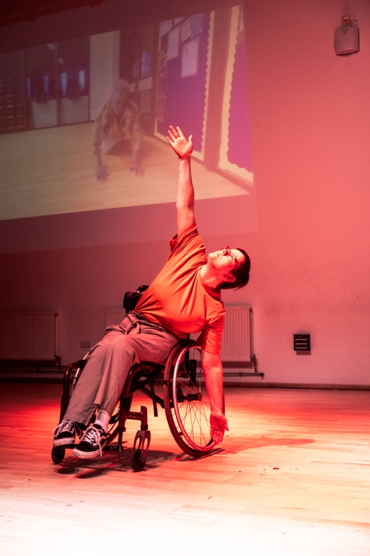
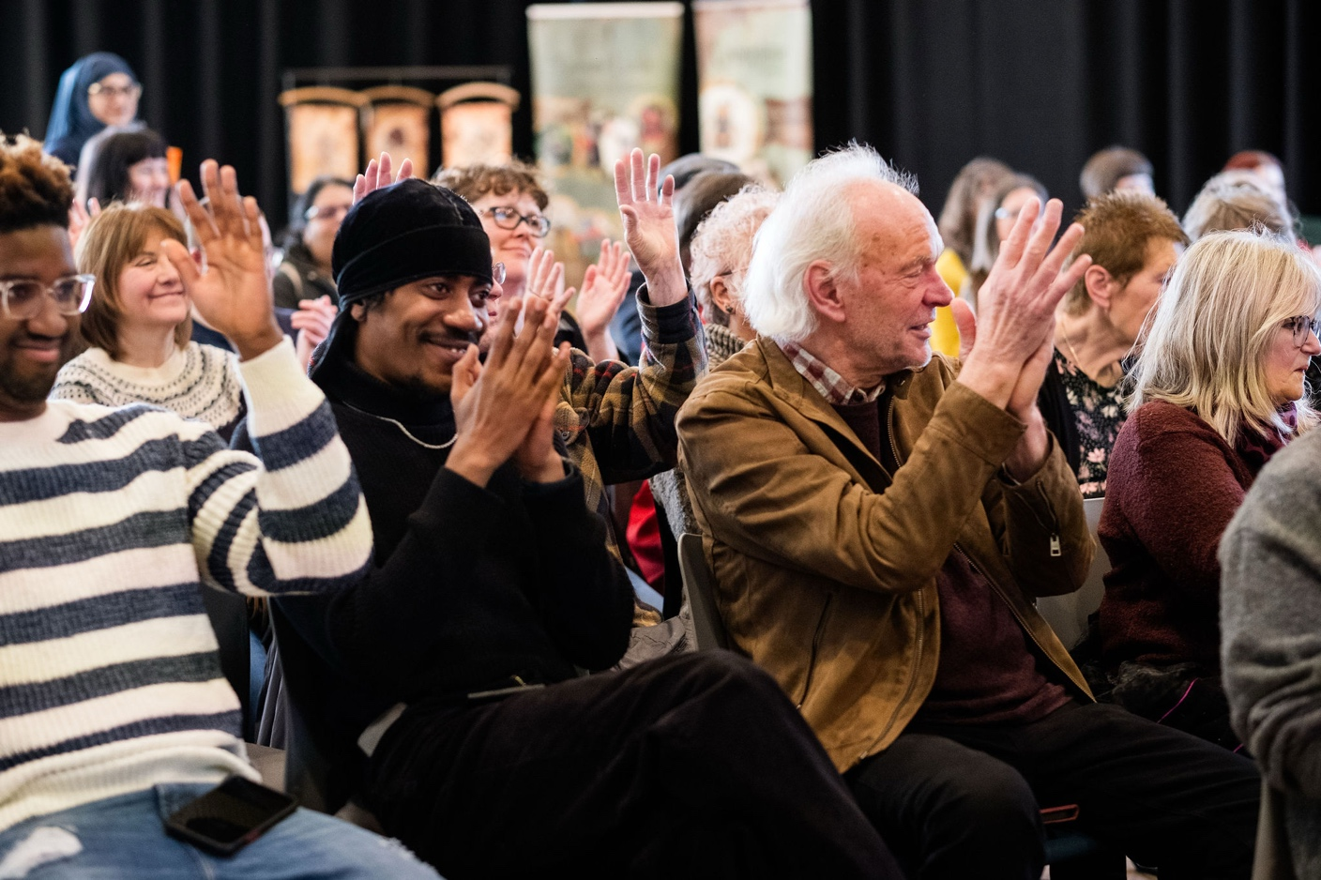
Thank You for your interest and time. We look forward to receiving your application!
